1.

A boolean value is is either true or false

3 different expressions:

-1 <= 2

-3== (2 + 4)

- “plan” != “schedule”

2.

Flowchart is the ﬂow of execution of the program , “Python’s moving ﬁnger”.

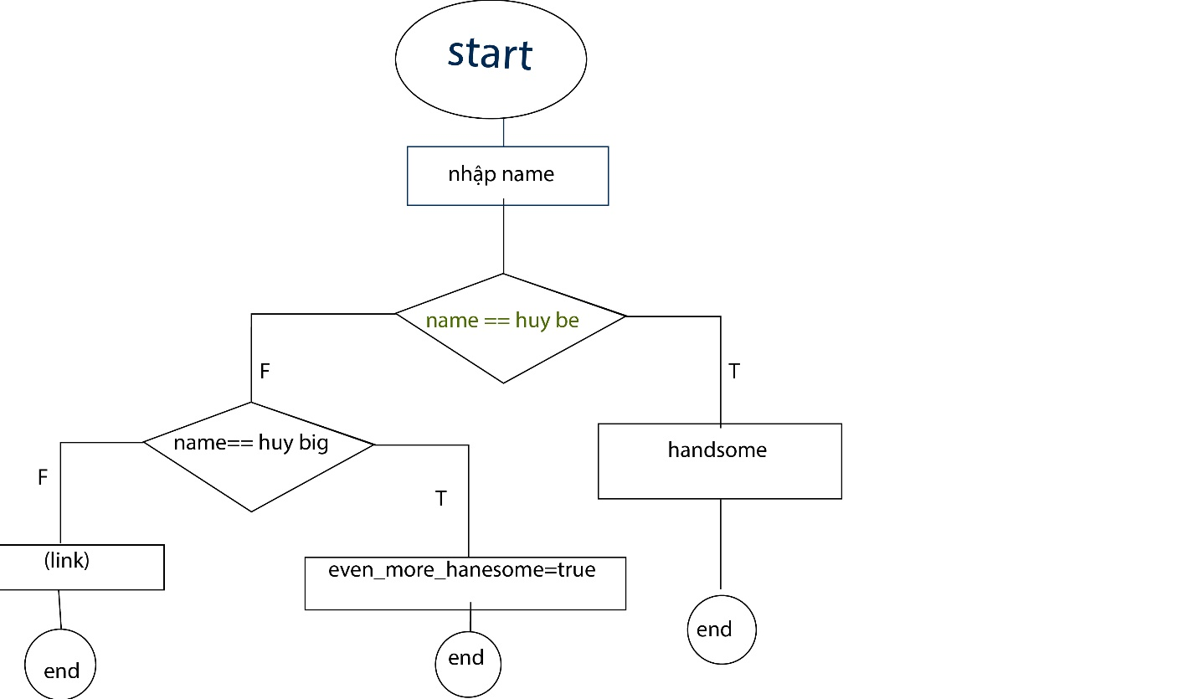

3.Nested conditional is a conditional inside a branch of another conditional.

if a%2=0 :

print(“ a la số dương ”)

else :

print(“a khong la so duong”)